6)
6) Heterogeneity

Heterogeneity is easy to account for using the modern approach. Graphically, the abscissa is a function of pressure and the ordinate is the amount adsorbed. Thus, if there are two energy plains, their χ-plots simply add. It is not rare to have two energies or type of plots to be present in the same sample. For example, one could have a sample that has large external surface area and the porosity is “microporous” and follows the log-law. Although this sounds complicated, one simply determines the log-law fit for the “microporous” part and use the χ-plot for the external area and add common energies amounts. This will be illustrated later, but first some mathematical logic.

Looking at two separate energy function pre-exponentials, E_{a}. The high E_{a} curve has the lowest value of χ, so one starts at that point. One fits a straight line to this high low energy χ-plot. One then can subtract this plot from the total to get the low energy curve. Below is a graphical representation of this.
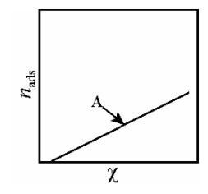  Figure 1 the χ-plot of the specimen A | 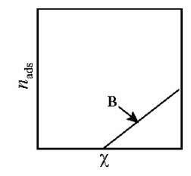  Figure 2 the χ-plot of the specimen B | 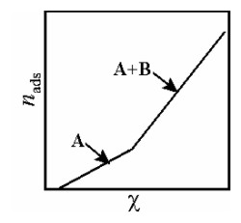Figure 3 Adding curves A and B
Looking at the first and second derivative of figure 3 one first gets a step function and then a δ function:
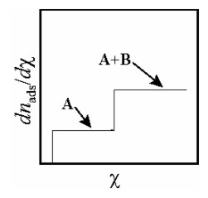  Figure 4 differentiating figure 2 once. | 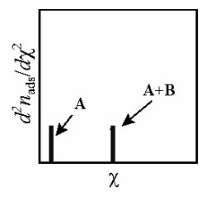  Figure 5 differentiating figure 2 twice
Figure 5 is the E_{a} distribution. But what if there is a different type of distribution other than two discreet peaks. This will be important not just for the heterogeneity but for porosity. I one has a normal distribution of E_{a}s the second integral of this is the original χ-curve.
The normal distribution used for statistics is the equation:
Equation 1
1st integral:
Equation 2
2nd intergral:
Equation 3
The function G is for a unit value for n_{ads}, in other words for θ, therefore these equation need to be multiplied by n_{m} for the isotherm:
Equation 4

The value <χ_{ς}> is the mean value for the χ_{ς}s and is the peak for the distribution. The ending Greek letter, ς, indicates the spread of <χ_{ς}>. This equation will be seen again for mesoporosity.

The output parameters are n_{m}, <χ_{ς}> and ς. So, the fit is expanded from 2 to 3. This is the first feature to expand the simple isotherm description. In doing so, one parameter has been replaced and one added.

If ς = 0 this equation would yield the original χ equation. If one wished to see what a homogeneous fit would be using a least squares routine that has ς as a variable, one cannot set it to zero since that generates an error. One must set it to an extremely low value to simulate zero.

Example of a simple fit to the heterogeneity fit:

An example of an isotherm that was carefully controlled to yield a standard curve is that by Krug, Jaroniec and Olivier.

An example of an isotherm that was carefully controlled to yield a standard curve is that by Krug, Jaroniec and Olivier (KJO.) The temperature seems to have been well characterized and controlled which is critical for a standard curve. The adsorbent was a silica sample LiChrospher Si-1000, which was apparently very pure with only slight heterogeneity. The adsorbate is nitrogen. The last two point listed in their Table 1 were from a different sample type (LiChrospher Si-5000) and is not used here, since it is unlikely to be chemically identical. In the KJO case, the temperature from the data was calculated to be about 0.01K too warm, which creates little problems and changes the output parameters very little. They must have taken special care to guard against this error, since, normally in the past, Micromeritics instruments lacked such control. The sample had slight heterogeneity. Both the heterogeneity and temperature correction were use for a 4-parameter fit and were not used for a 2-parameter fit.
There parameters are provided in Table 1. Figure 6 is a plot of the data using the 4-parmater fit. It made little difference overall to the 2-parameter fit, but the heterogeneity make a large relative difference at low pressures.

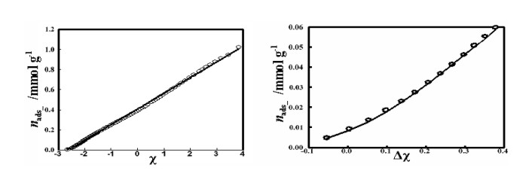
Figure 6 Data by JKO for a standard N₂ isotherm. The left graph shows fit on full χ-plot. The right graph show the low-pressure data on a Δχ plot. To the eye, there seems to be little difference between the linear fit and the Z distribution fit.

Table 1 parameters from data by JKO
With Z distribution: | With heterogeneity |  | linear: | Ignoring heterogeneity
〈χ_{ς}〉 = | -2.6123 * |  | χ_{ς} = | -2.6213 *
〈E_{a}〉 = | 8.84 kJ mol⁻¹ |  | E_{a} = | 8.92 kJ mol⁻¹
ς = | 0.2048 *
n_{m} = | 0.1561 mmol g⁻¹ * |  | n_{m} = | 0.156 mmol g⁻¹ *
IUPAC A = | 152.6 m² g⁻¹ |  | IUPAC A = | 152.0 m² g⁻¹
P_{vap} = | 1.0089 bar *
σ (fit) = | 7.63×10⁻⁵ mmol g⁻¹ |  | σ (fit) = | 9.14×10⁻⁴ mmol g⁻¹
% range = | 0.0030% |  | % range = | 0.036%
A criterion normally used, for QM, is what is the standard deviation as a function of the full range of data. The normal percent full range that is used for the QM fit has been <1%. Hopefully, the experimental data is good to at least this value. In this case the fit, even without the heterogeneity or P_{vap} correction, is excellent. However, using the Z distribution is better by a factor of 10. (It is unusual for the BET fit to be < 1% using the high pressure Rouquerol criterion and low pressure of 0.05 P/P_{vap}. Of course, it is far from fitting if one uses pressures below or above these ranges.)
One would think that if there is heterogeneity that the mesopore onset would be affected by this. The is probably incorrect since the energy of adsorption is a function of χ and not of Δχ. It had been previously assumed that the distribution for pore size would be dependent upon the heterogeneity, but this could only be correct if there were, for some reason, coordination between the two. If the heterogeneity were distributed evenly, it should not affect the pore dimension calculation.

Contrary to what is written in the 1st and 2nd edition of my book.
M. Jaroniec, M. Kruk, J. P. Olivier, Langmuir 15 (1999) 5410-5413.Krug, Jaroniec and Olivier.

