9) Adsorption of two adsorptives simultaneously:

It is difficult to find appropriate literature on binary adsorption that is useful in order to make calculations with the QM/ESW hypotheses. The approach to this is simple, but the mathematics could become tedious. It seems obvious, that if two adsorbates have about the same E_{a}, that the mixture is likely to behave like a single adsorbate, except for some modification to the “layers” above the 1st “layer.” In which case the additional “layers” should approximate the behavior of the bulk liquid adsorptive.

On the other hand, if there is a big difference between the two E_{a}/RTs, the one that has the most exothermic E_{a}/RT (call it “A”) will fill most of the first “layer” before the least exothermic one (designated “B”) has an opportunity. Thus, the B will have little influence on the adsorption of A in the first “layer.” In subsequent “layers” the ratio of A to B would approach the bulk liquid composition. There is probably an exponential decay going into the liquid in a similar fashion as the Debye-Hückel theory. This has been demonstrated in other systems using Darken’s equations and Poisson’s equation to obtain equilibrium. If there are mesopores, then this is also true after the pore filling has occurred.

Thus, one should be able to calculate the binary adsorption curve given only the isotherms of the two adsorbates and the adsorptive binary phase diagrams, which are probably available. (If the adsorptive binary phase diagrams are not available, many binary mixtures can be approximated with a regular solution calculation.) This would save considerable effort and should be quite useful at least for screening studies. This could save considerable effort in screening studies. For X adsorbates and P pressures, the number of experiments that need not be run is (1-X)XP which could be considerable

In Table 1 is a procedure to take advantage of binary mixture where the E_{a}/RTs are different enough. Notice that only the χ-values associated with the lowest value of χ, listed as the “A” adsorbate, is used for plotting.

Table 1: Steps to calculate the binary diagrams when χ_{ς}(A) << χ_{ς}(B)
1) | Do the χ-plot for both adsorbates
2) | Determine what total pressure you wish to have the phase diagram for. (call this p'.)
3) | From the χ-plots, determine which adsorbate has the lowest value for χ_{ς}. It may be difficult to do this, so try determining the value of χ_{ς} from the log-law plot. (This adsorbate with the lowest χ_{ς} is adsorbate “A,” labelled “χ_{ς}(A)”)
4) | Determine the value of n_{ads} from both isotherms of the adsorbates at pressure p'. Designated these n_{A}(p') and n_{B}(p')
5) | Draw straight lines from for  A: (χ, n_{A}) =  (χ_{ς}(A),0) to (χ(p’(A)), n_{A}(p')) | and for  B: (χ, n_{B}) =  (χ_{ς} (A!*), n_{B} (p’)) to (χ(p’(A!*)),0)
The “!” is placed here to emphasize that one uses only the χ values for A.

The diagram below illustrates the method. In the single adsorbate isotherms, component A has the lowest χ_{ς} (largest exothermic adsorption energy) so the abscissa is specified by it. The four points needed are shown in parenthesis.

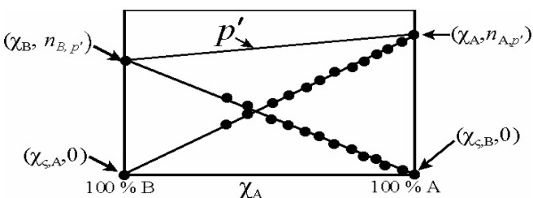
Figure 1 Diagram that illustrates the method for a binary adsorption, using the method described in Table 1.

The data points are matched pairs in the binary experiment. The abscissa is χ of A the species with the highest value of -E_{a}/RT. The low -E_{a}/RT, B, as the abscissa does not yield a straight line. (This phenomenon is referred to as the “strong Henry’s law” species in classical calculations.)

Examples:

The data being analyzed is by Danner and Wenzl for the gases CO, N₂ and O₂ on 5A and 10X zeolite. The temperature was 144.3 K. The P_{vap} was calculated from data by Clayton and Giauque for O₂ and CO and extrapolation of the Dortmund data base compilation for N₂. There may be some error is these data, but the Dortmund data base seems quite self-consistent.

The ✕s and +s are the data and black lines are least squares fit. The dashed lines are the χ-plot modeling.
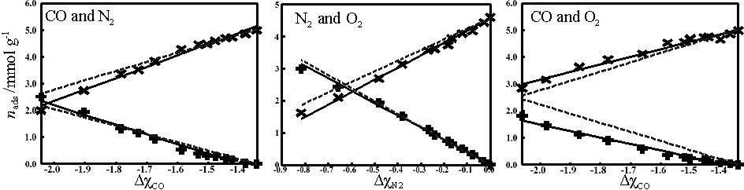
Figure 2 The Δχ binary plot of the binaries CO-N₂, N₂-O₂ and CO-O₂ on 5A zeolite.
From the calculate lines the conventional phase diagram can be formed:

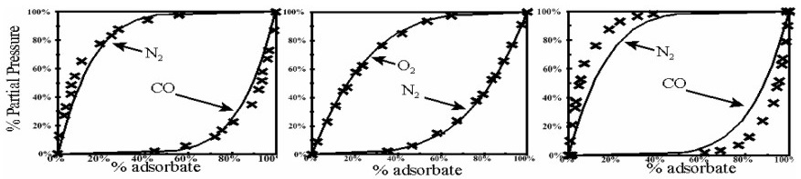
Figure 3 The binary phase diagrams formed from the Δχ plots of the binaries CO-N₂, N₂-O₂ and CO-O₂ on 5A zeolite. Data is by Danner and Wenzl.

Two of these calculations seem very good but the CO-O₂ diagram is quite a bit out of line. However, both the data and the fit are very different from the binary mixtures in the bulk liquid.
The following are the similar graphs for 10X zeolite:
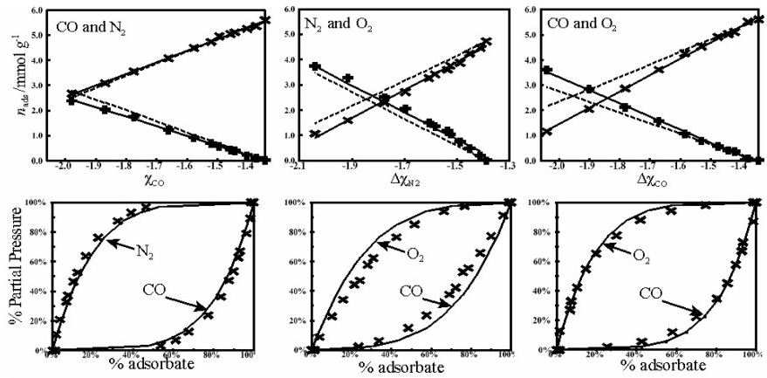
Figure 4 The binary Δχ plots and the binary adsorption phase diagram from the data by Danner and Wenzl of CO-N₂, N₂-O₂ and CO-O₂ mixtures on 10X zeolite.

The 10X is a little better than the 5A. Both however are not as accurate as one would like them to be. They are certainly good enough to determine if the combinations are suitable for further study.

Conclusion – binary adsorption

It was demonstrated in this section that the calculation of the binary adsorption isotherms from the individual isotherm outputs is probably possible. Hardly any binary isotherm is ideal and in real situations the adsorption will need to take into consideration the binary bulk isotherm. Thus, the first layer will be solved using the isotherm output parameters and the subsequent layers will probably require the information from the bulk liquid diagrams. At any rate by taking into account the quantum nature of adsorption seems to be a step forward and much work is yet to be performed.

Condon and Schober
D. Basmadjian, “The Little Adsorption Book, CRC Press, Boca Raton, FL, USA, Chapter 8.
R. P. Danner and L. A. Wenzl, AIChE Journal, 15(4) (1969) 515- 520.
J. O. Clayton and W. F. Giauque, J. Am. Chem. Soc. 54 (1932) 2610-2626
Dortmund Data Base, DDB #1057, “Nitrogen,” CAS = 7727-37-9.

